Muhammad Zain Ali
22I-0562
Lab 10
Programming language
27 Oct 2022

Task1 :

#include<iostream>
using namespace std;

void display (){
cout << "It was narrated from Umm Salamah that when the Prophet (PBUH) performed the Subh (morning prayer), while He (PBUH) said the Salam, He (PBUH) would say:\n'Allahumma inni as'aluka' ilman nafi'an, wa rizqan tayyiban, wa 'amalan mutaqabbalan (O Allah, I ask You for benificial knowledge, good provision and acceptable deedsd).' -Sunan of Ibn Majah, Vol.1, Book 5, Hadith 925\n";
}

int main()
{
display();

return 0;
}
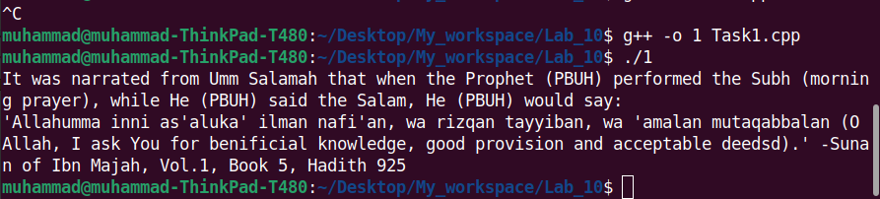

Task 2:

#include <iostream>
#include <climits>
using namespace std;

void limits(){
cout <<"The upper limit of integer is: "<<INT_MAX<<endl;
cout <<"The lower limit of intiger is: "<<INT_MIN<<endl;
}

int main() {
limits();

return 0;
}

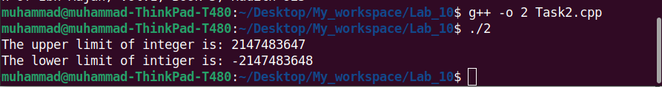

Task 3:

#include <iostream>
using namespace std;

float volumeof( float radius) {
float volume = (4/3)*3.14*radius*radius*radius;
cout <<volume<<endl;
return volume;
}

int main() {

float radius;

cout <<"Enter the radius of sphere to calculate its volume: ";
cin >> radius;
cout <<"Volume is: ";
volumeof(radius);

return 0;
}

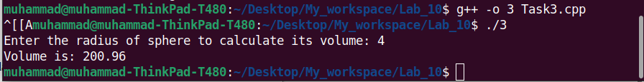

Task 4:

#include <iostream>
using namespace std;

int num;

int timesHundred(int num) {
int product = num *100;
cout <<product<<endl;
return product;
}

int main () {

cout <<"Enter a number to multiply it by 100: ";
cin >> num;
cout <<"Product of this number with 100 is: ";
timesHundred(num);

return 0;
}

